|  |  |  |  |  |  |  |  |  |  |
| --- | --- | --- | --- | --- | --- | --- | --- | --- | --- |
|  |  |  | **CL117** | | |  |  | **LAB 06** |  |
|  | I |  |  |  |  |  |  |  |
|  | **INTRODUCTION** | | | | |  |
|  |  |  | **MS Access and its features/Quries SQL** |  |
|  |  |  |  |  |  |  |  |  |
|  | **TO ICT** | | | | |  |
|  |  |  |  |  |
|  | | | | | | |  | |  |
|   **NATIONAL UNIVERSITY OF COMPUTER AND EMERGING SCIENCES** | | | | | | | | |  |

## **What is DBMS?**

Database Management Systems (DBMS) are software systems used to store, retrieve, and run queries on data. A DBMS serves as an interface between an end-user and a database, allowing users to create, read, update, and delete data in the database.

## **What is RDBMS?**

RDBMS stands for Relational Database Management System. RDBMS is a program used to maintain a relational database. RDBMS is the basis for all modern database systems such as MySQL, Microsoft SQL Server, Oracle, and Microsoft Access. RDBMS uses [SQL queries](https://www.w3schools.com/sql/default.asp) to access the data in the database.

## **What is a Database Table?**

A table is a collection of related data entries, and it consists of columns and rows.

A column holds specific information about every record in the table.

A record (or row) is each individual entry that exists in a table.

Look at a selection from the Northwind "Customers" table:

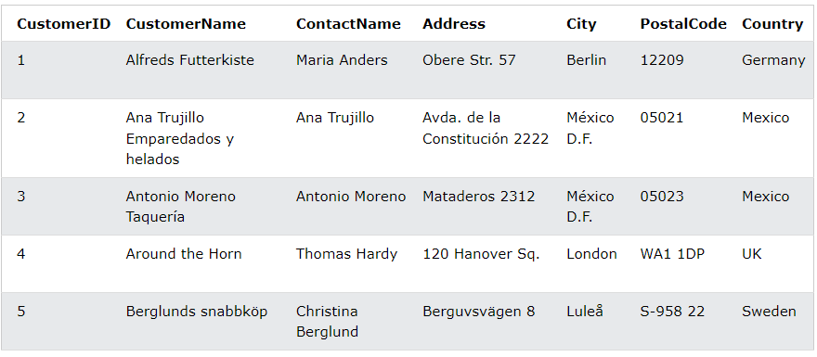

## **What is a Relational Database?**

A relational database defines database relationships in the form of tables. The tables are related to each other - based on data common to each.

Look at the following three tables "Customers", "Orders", and "Shippers" from the Northwind database:

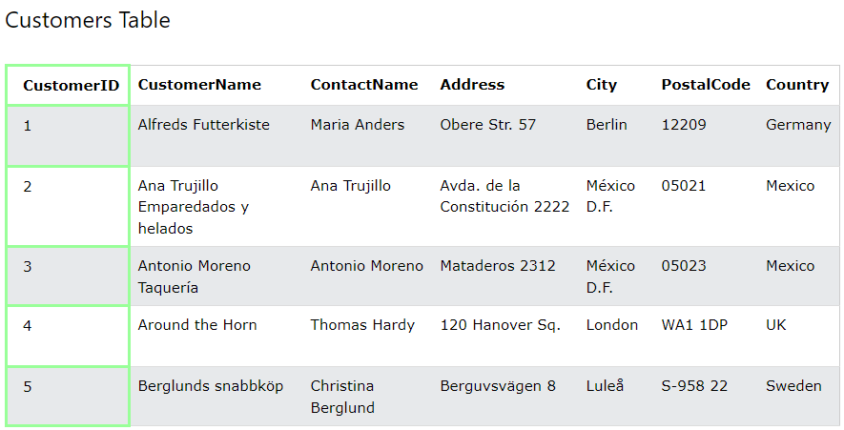

The relationship between the "Customers" table and the "Orders" table is the CustomerID column:

The relationship between the "Orders" table and the "Shippers" table is the ShipperID column:

## **What is SQL?**

SQL is the standard language for dealing with Relational Databases.

SQL is used to insert, search, update, and delete database records.

## **The MySQL SELECT Statement**

The SELECT statement is used to select data from a database.

The data returned is stored in a result table, called the result-set.

## **The MySQL WHERE Clause**

The WHERE clause is used to filter records.

It is used to extract only those records that fulfill a specified condition.

# SQL CRUD Operations

# CRUD is an acronym for CREATE, READ(SELECT), UPDATE, and DELETE statements in SQL Server.

## **The SQL CREATE TABLE Statement**

The CREATE TABLE statement is used to create a new table in a database.

## **The SQL READ(SELECT) Statement**

The SELECT statement is used to select data from a database.

## **The SQL UPDATE Statement**

The UPDATE statement is used to modify the existing records in a table.

## **The SQL DELETE Statement**

The DELETE statement is used to delete existing records in a table.

**What is Microsoft Access?**

**Microsoft Access** is a Database Management System offered by Microsoft. It uses the Microsoft Jet Database Engine and comes as a part of the Microsoft Office suite of application.

Microsoft Access offers the functionality of a database and the programming capabilities to create easy to navigate screens (forms). It helps you analyse large amounts of information and manage data efficiently.

## Important Terms and Basic Objects

Now in this Microsoft Access tutorial, we will learn about some important terms and basic objects in MS Access:

### Database File

It is a file which stores the entire database. The database file is saved to your hard drive or other storage devices.

### Datatypes

Datatypes are the properties of each field. Every field has one datatype like text, number, date, etc.

### Table

* A Table is an object which stores data in Row & Column format to store data.
* A Table is usually related to other tables in the database file.
* Each column must have Unique name.
* We can also define Primary Key in a table.

### Query

* Queries answer a question by selecting and sorting and filtering data based on search criteria.
* Queries show a selection of data based on criteria (limitations) you provide.
* Queries can pull from one or more related Tables and other Queries.
* Types of Queries can be SELECT, INSERT, UPDATE, DELETE.

### Form

* A form is a database object that you can use to create a user interface for a database application.
* Forms help you to display live data from the table. It mainly used to ease the process of data entry or editing.

### Report

* A report is an object in desktop databases primarily used for formatting, calculating, printing, and summarizing selected data.
* You can even customize the report’s look and feel.

**Microsoft Access Data Types**

MS Access common data types are listed below:

| **Type of Data** | **Description** | **Size** |
| --- | --- | --- |
| Short Text | Text, including numbers which does not need calculation. (e.g., Mobile numbers). | Up to 255 characters. |
| Long Text | This data type is used for lengthy text or alphanumeric data. | Maximum 63, 999 characters. |
| Number | Numeric data type used for storing mathematical calculations. | 1, 2, 4, 8, and 16 bytes. |
| Date/Time | Store Date/time for the years 100 through 9999. | 8 bytes. |
| Currency | It allows you to store currency values and numeric data with one to four decimal places. | 8 bytes. |
| Auto Number | Assign a unique number or assigned by Microsoft Access when any new record is created. Usually used as the primary key | Four bytes (16 bytes if it is set as a Replication ID). |
| Yes/No | It only stores logical values Yes and No. | 1 bit |
| Attachment | It stores files, such as digital photos. Multiple files can be attached per record. | Up to 2GB Data can be stored. |
| OLE objects | OLE objects can store audio, video, other Binary Large Objects. | Up to 2GB data can be stored. |
| Hyperlink | Text or combinations of text and numbers stored. That text is used as hyperlink address. | Each part of a Hyperlink data type allows you to store a maximum 2048 characters. |
| Calculated | Helps you to create an expression that uses data from one or more fields. | You can create an expression which uses data from one or more fields. |

## How to Create a Database

Before we create a Database, lets quickly understand the holistic picture of what Database is, with particular reference to MS Access.

Let’s, start with a few real-life Microsoft Access databases example:

* We have Bookcase where Books resides,
* We have i-pods where we have a collection of music & cases are countless.

Similarly, we have MS Access Database is a kind of home for all your Tables, Queries, Forms, Reports, etc. in MS Access which are interlinked.

Technically, Database store the data in a well-organized manner for easy access and retrieval.

## Create a Database

### Create a Blank Database

**Step 1)** With MS Access application open, Click on File > New

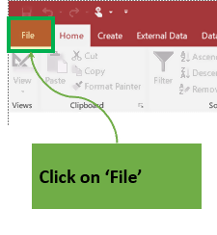

**Step 2)**Click on ‘Blank Database.’

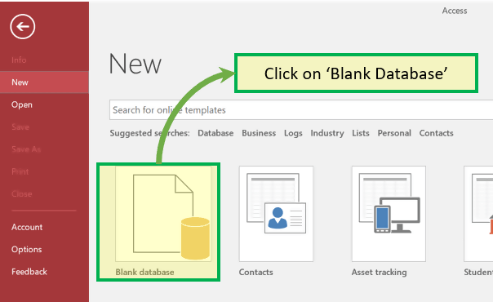

**Step 3)**File name box will appear with the default file name.

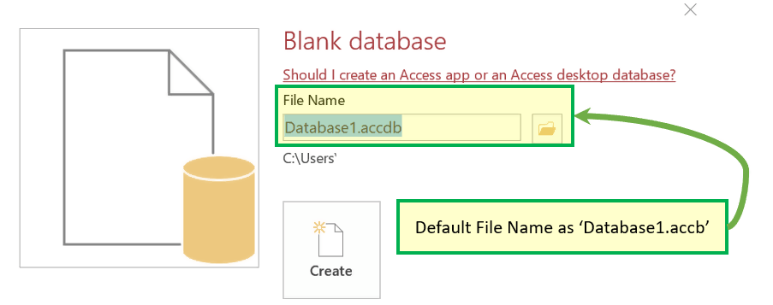

**Step 4)**Enter the new name.

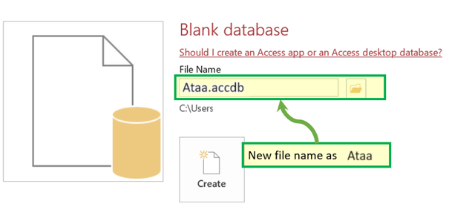

**Step 5)** Click on **‘Create.’**

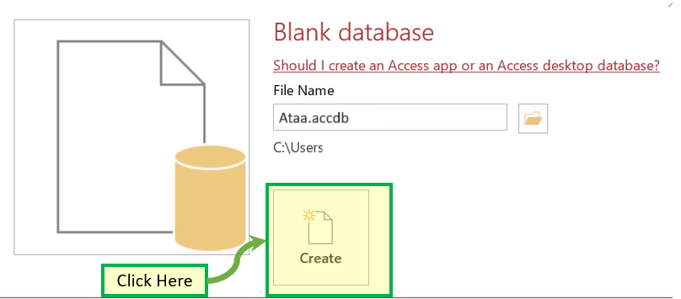

**Result:**Ataa Database created and below window will appear.

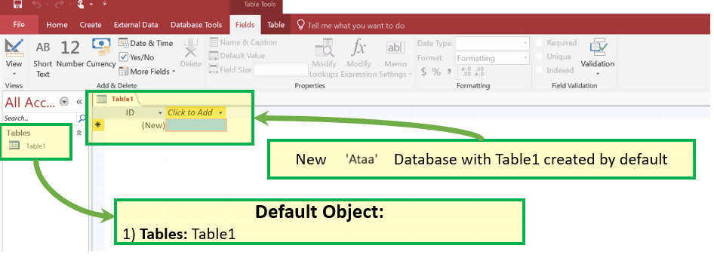

**How to Create Table**

The first step in this Microsoft Access tutorial to store data in the database is creating a Table where data will reside. Post creation of the table, we can keep inserting the rows in the table.

**Create Table – Design View**

**Step 1)** First Click Create tab. Then from Tables group, click Table. 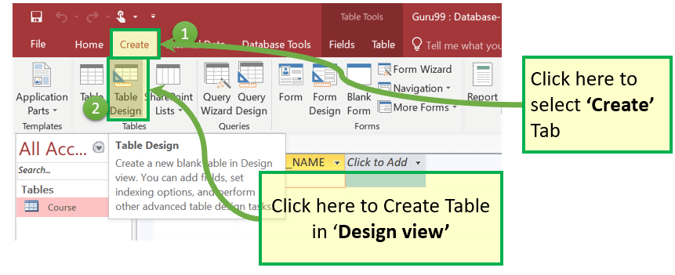

**Step 2)** Table Dialog box appears. For each Field enter **Filed Name, Data Type**and**Description.**

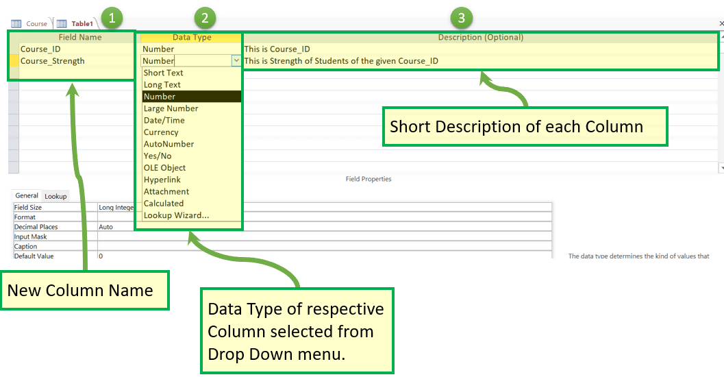

**Steps 3)** To Add Course_ID as Primary Key, select it and Click on ‘Primary Key.’ Course_Id will be Preceded by KEY ICON as shown below:

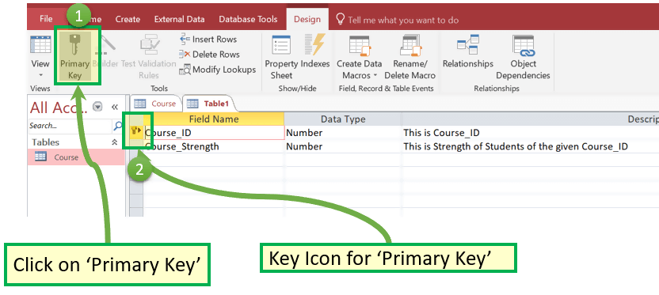

**Steps 4)**Press ‘Ctrl+S.’ Enter the Table Name and Click OK

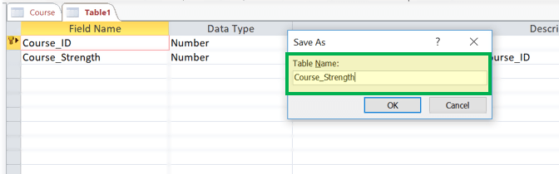

**Result:**

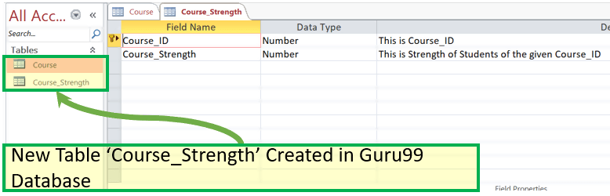

### How to Switch views between Datasheet and Design

Now in this MS Access tutorial, we will learn how to switch views between Datasheet and Design:

To switch views, between the datasheet (spreadsheet view) and the design view, click the **‘View’**button in the top-left hand corner of the Access Ribbon (shown in the Home/Help/Design Tabs). And Click on the View you need to display.

For Example: Let’s Assume You want to switch to the newly created table ‘Course_strength’ from ‘Design view’ to ‘Data Sheet’ View.

**Step 1)**Click on Datasheet View

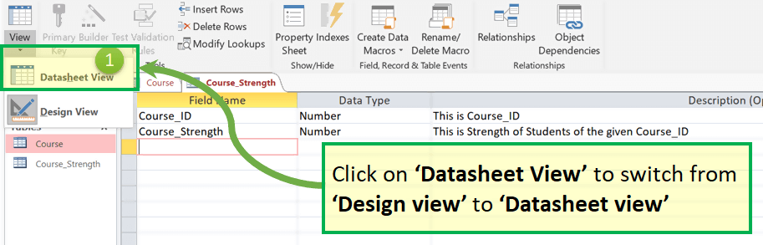

**Result:**

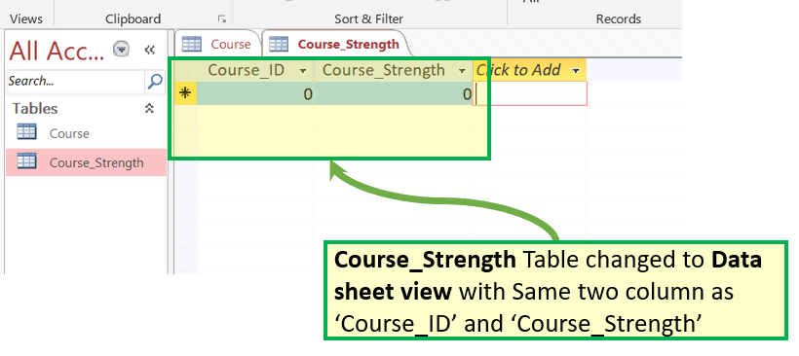

**Forms in MS Access**

* A form is a database object that you can use to create a user interface for a database application.
* It mainly used to ease the process of data entry or editing.
* Data in a form can be selected from one or more tables.
* Forms can also be used to control access to data, like which fields or rows of data are visible to which users.
* Forms have a Form View.
* Help you to display live data with easy creation of new data.

To understand form lets first create **two new Record in**Contact Table (from the prebuilt Contact Database discussed here)

**Step 1)** Select the ‘Contact’ table from Left Navigation.

**Step 2)** Create two rows by entering some relevant data in two rows.

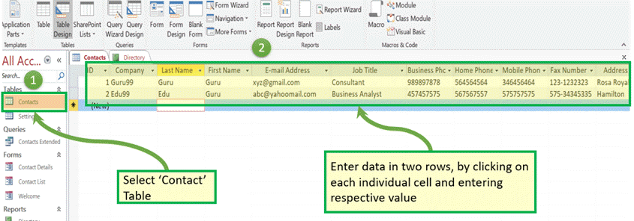

create Form, and then we will see how forms can be leverage for easy display, editing, and creation of new data.

### How to Create a form

### Create using Form

t is the simplest way to create the form which will:

* By default, populate all the column from the selected table in ‘form view,’
* The user can delete non-required column manually

**Step 1)** Select the table for which we want to create the form and click on ‘Form.’

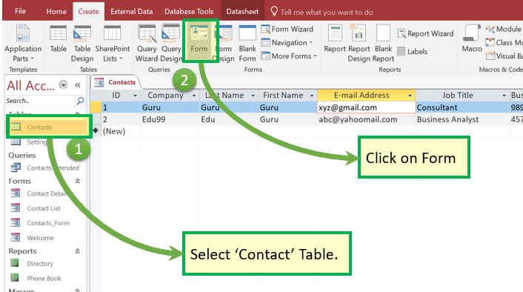

**Step 2)** Below window will appear.

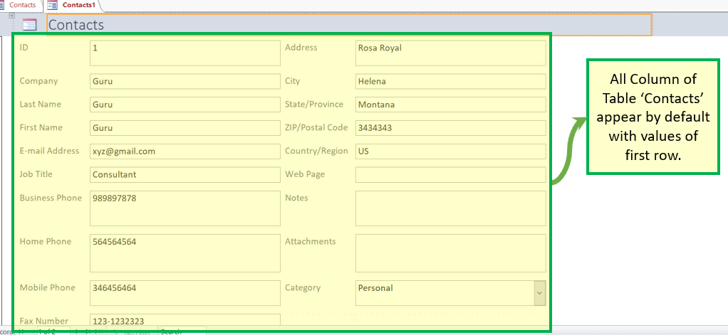

**Step 3)** Right-click on any cell which we don’t want to be part of final forms and click on ‘Delete.’

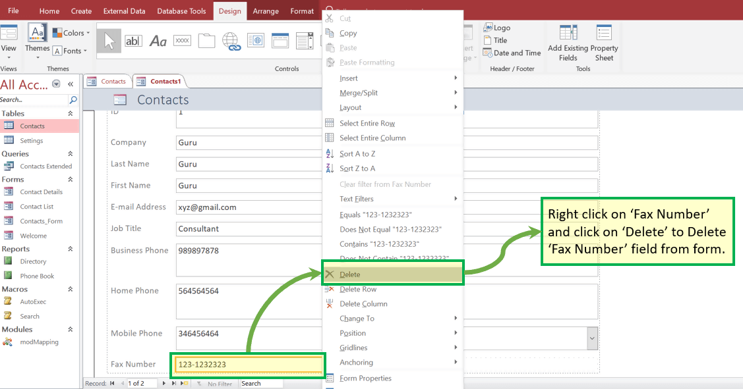

**Result: ‘**Fax Number**‘ field does not exist now.**

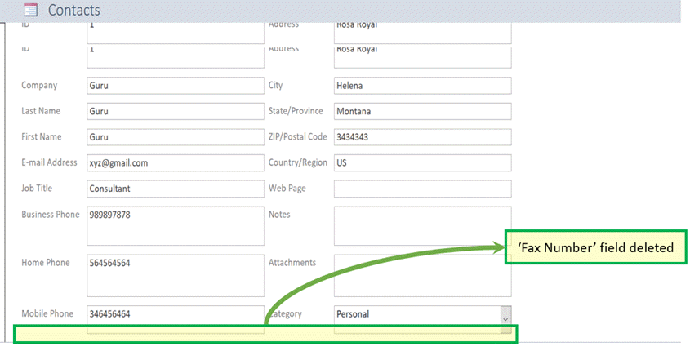

**Step 4)** Press ‘Ctrl+S’ and enter new Form Name as ‘Contact_Form2’. Click ‘OK’.

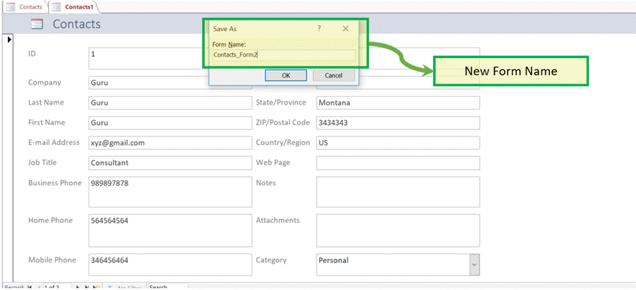

**Result:**New form with the name as **‘Contact_Form2’** exists under the “Forms” section.

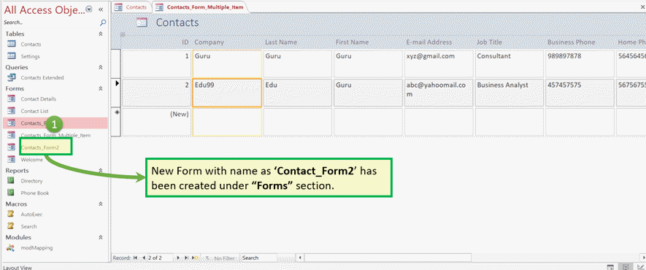

**Report**

* A report is an object in MS Access that is designed for formatting, calculating and printing selected data in an organized way.
* It contains information from tables and also information that are there in the report design.
* Reports are helpful as they allow you to present all information of your database in an easy-to-read format.

Let’s take an MS Access databases example of**‘Contact’**DB default report – ‘Phone Book.’

**Step 1)** Click on ‘Phone Book’ under ‘Report’ section. The system will open the inbuilt ‘Phone Book’ report.

It will display Contact Name, Home, Business and Mobile name displayed

for each record present.

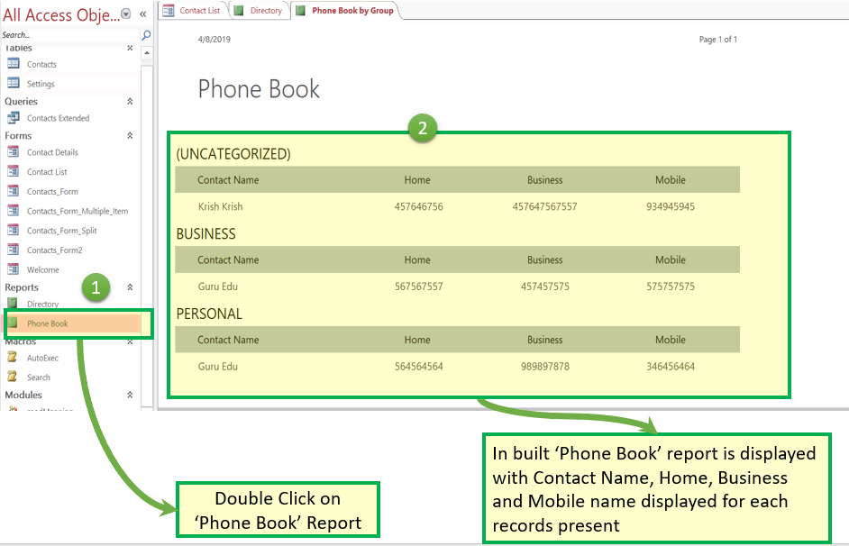

**Step 2)**Now suppose that we want to edit the report Heading from ‘Home’ to ‘Home Number.’ Right click and click on ‘Design View.’

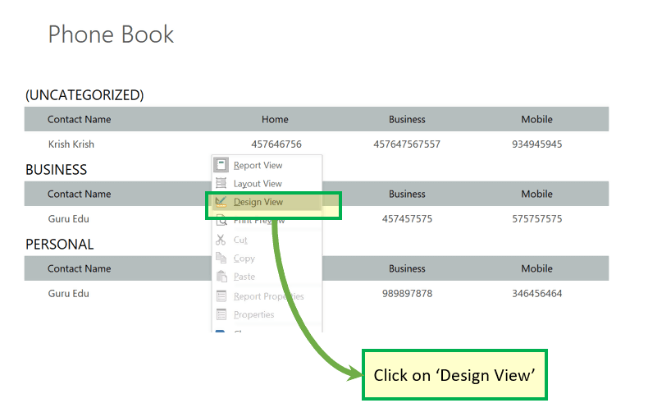

The system will open the Report in Design view.

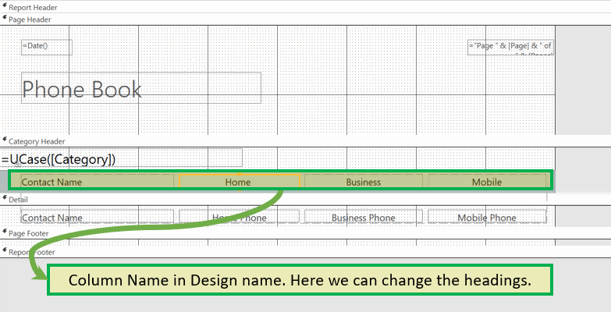

**Step 3)** Edit the name you want to update and Press ‘Ctrl+S’.

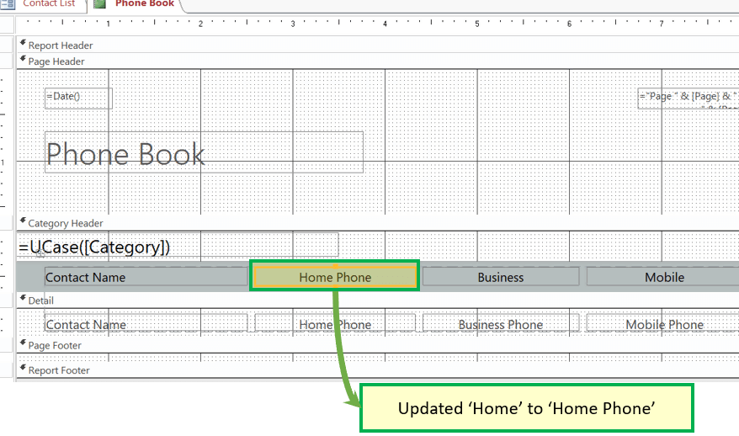

**Step 4)**Double click ‘Phone book’ under reports

**Result:**Label is updated from ‘Home’ to ‘Home Phone.’

